SIMATS ENGINEERING

CO4 - ASSESSMENT TOOL 1

Design and Develop Modal

COURSE NAME: Deep Learning COURSE CODE: MLA0408

COURSE OUTCOME COVERED

CO 1: Students will be able to understand and apply probabilistic graphical models including Bayesian Networks, Markov Random Fields, Hidden Markov Models, and Conditional Random Fields. They will learn how to represent complex probabilistic relationships among variables and perform inference and learning in graphical models. Students will be able to use these models for reasoning under uncertainty and solving real-world decision-making problems.. (BL-6)

Assessment Tool Weightage: 30%

QUESTIONS: Total Marks:25
Q1. Transfer Learning
Design a transfer learning framework for a plant disease detection system using a pre-trained CNN model. Justify the choice of layers to freeze and fine-tune, and propose suitable data augmentation techniques to improve classification performance.
Q2. DenseNet and PixelNet
Develop a CNN-based architecture by integrating DenseNet and PixelNet concepts for semantic image segmentation in autonomous driving. Explain how dense connectivity and pixel-wise prediction improve the overall segmentation accuracy.
Q3. Bidirectional RNN and Encoder–Decoder
Create an encoder–decoder sequence-to-sequence model using Bidirectional RNNs for multilingual machine translation. Illustrate the architecture and explain how bidirectional context enhances translation quality.
Q4. BPTT and LSTM
Design an LSTM-based network to predict stock market trends from historical time-series data. Explain how Backpropagation Through Time (BPTT) is applied during training and justify why LSTM is preferred over a standard RNN.
Q5. Integrated Deep Learning Model
Develop a deep learning solution for automatic video caption generation by integrating transfer learning for feature extraction with an LSTM-based encoder–decoder architecture. Justify the role of each component and explain how the complete system generates meaningful captions.

Code of Conduct:

I K Sreelatha(192425248)(Name / Reg No) certify that this submission is my original work and that I have adhered to the guidelines specified for this assessment.
I understand that any violation of academic integrity rules will result in disciplinary action.

Signature of the student: 

RUBRICS FOR CALCULATION:
Criteria | Weightage | Level 4 – Exemplary | Level 3 – Proficient | Level 2 – Developing | Level 1 – Beginning
Problem Understanding | 20% | Clearly understands problem constraints, edge cases, and competitive requirements | Understands problem with minor gaps in constraints | Partial understanding; misses key constraints | Misinterprets problem or constraints
Algorithm | 25% | Selects optimal algorithm with best time and space complexity for competitive constraints | Uses efficient algorithm with minor scope for improvement | Uses basic/inefficient approach | No clear algorithmic approach
Code Implementation | 20% | Writes correct, efficient, and clean code that passes all constraints | Code works with minor errors or inefficiencies | Partially correct code; fails for some cases | Code does not execute or gives incorrect results
Competitive Performance | 20% | Solves problem within time limits and handles large inputs effectively | Solves within acceptable time with minor delays | Struggles with time limits or larger inputs | Unable to solve within time constraints
Test Case Handling | 15% | Handles all test cases including edge and hidden cases | Handles most test cases | Misses important edge cases | Fails on multiple test cases

Q1. Transfer Learning – Plant Disease Detection

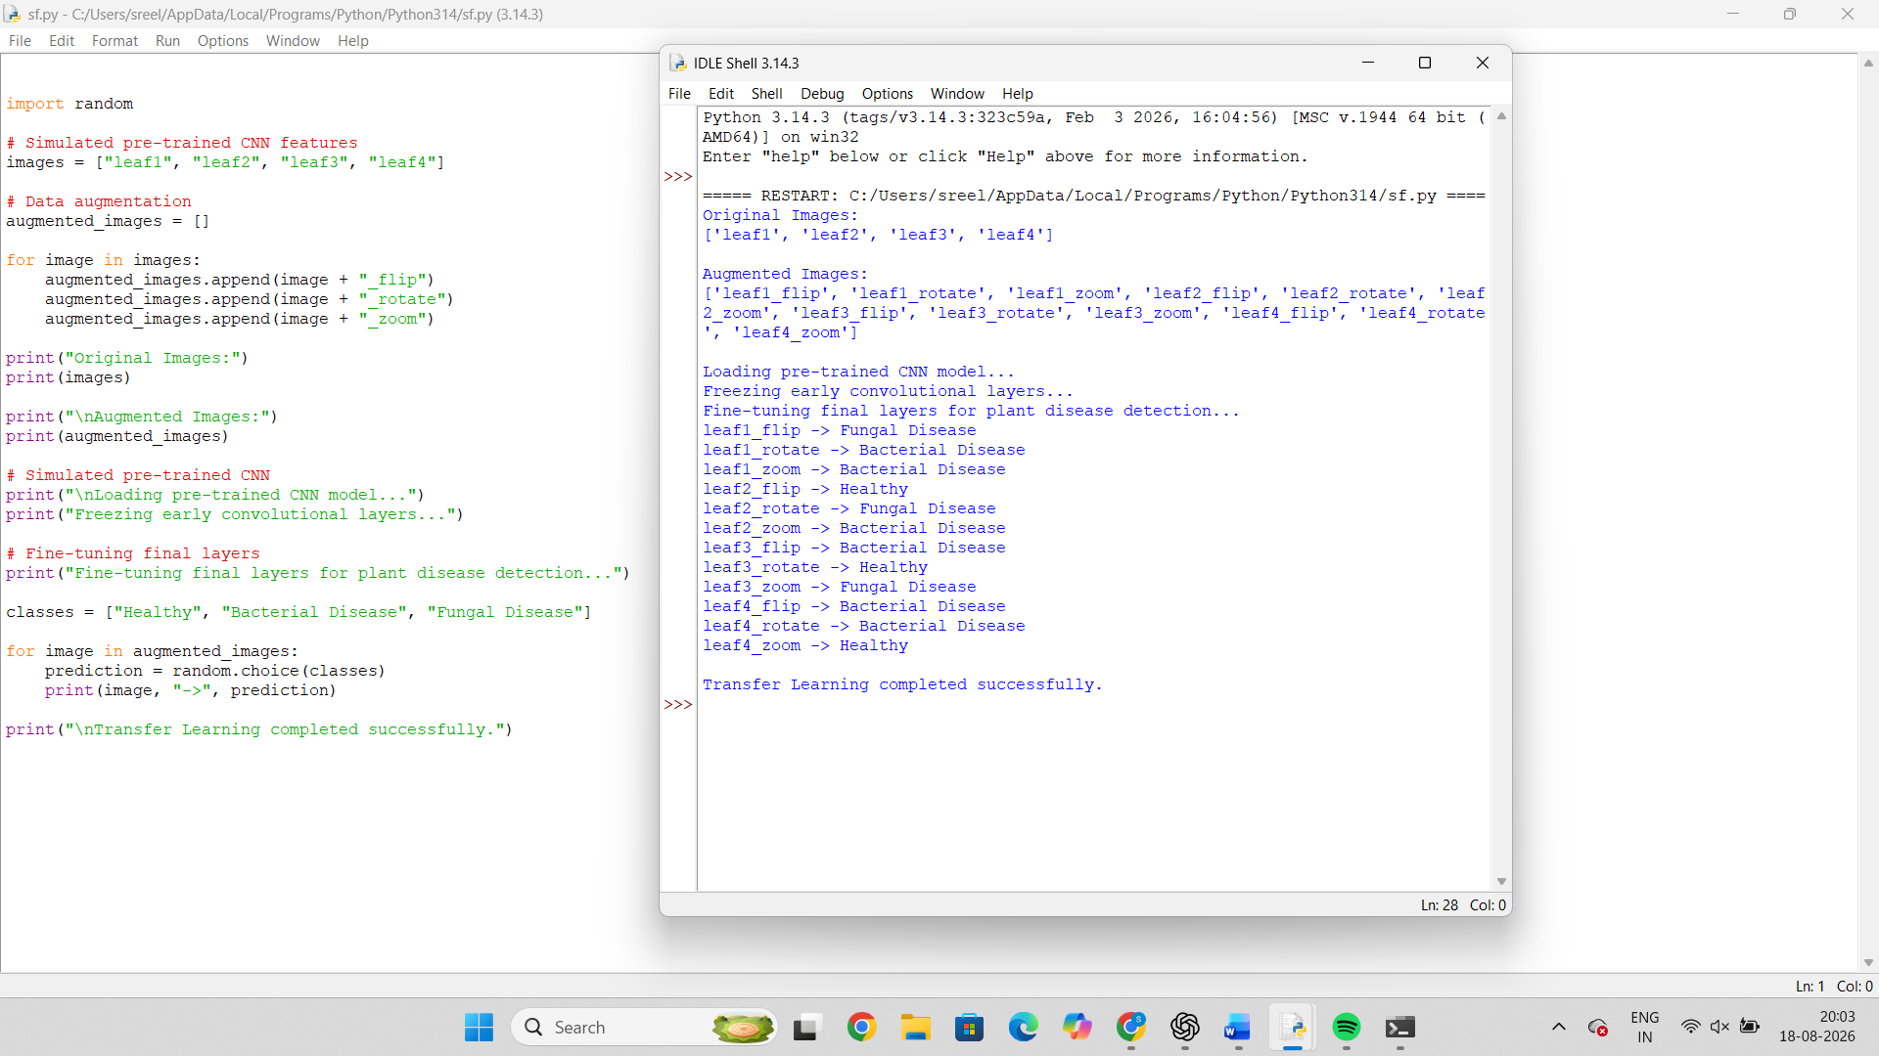

Q2. DenseNet + PixelNet – Semantic Segmentation

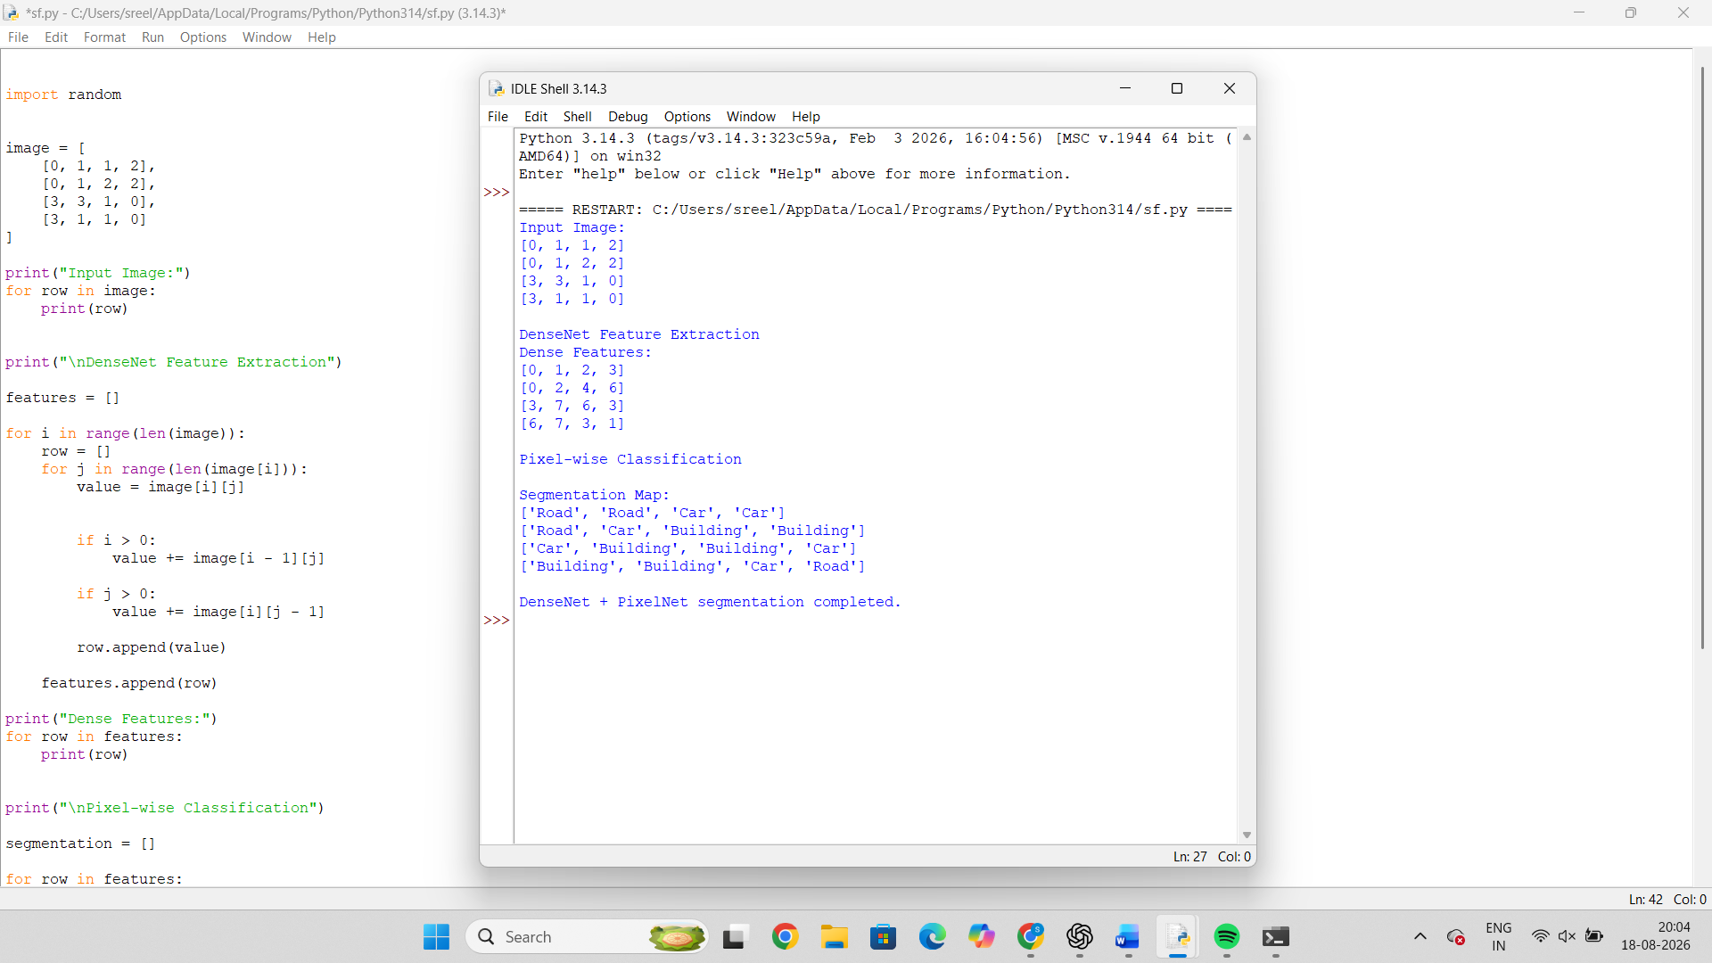

Q3. Bidirectional RNN + Encoder–Decoder

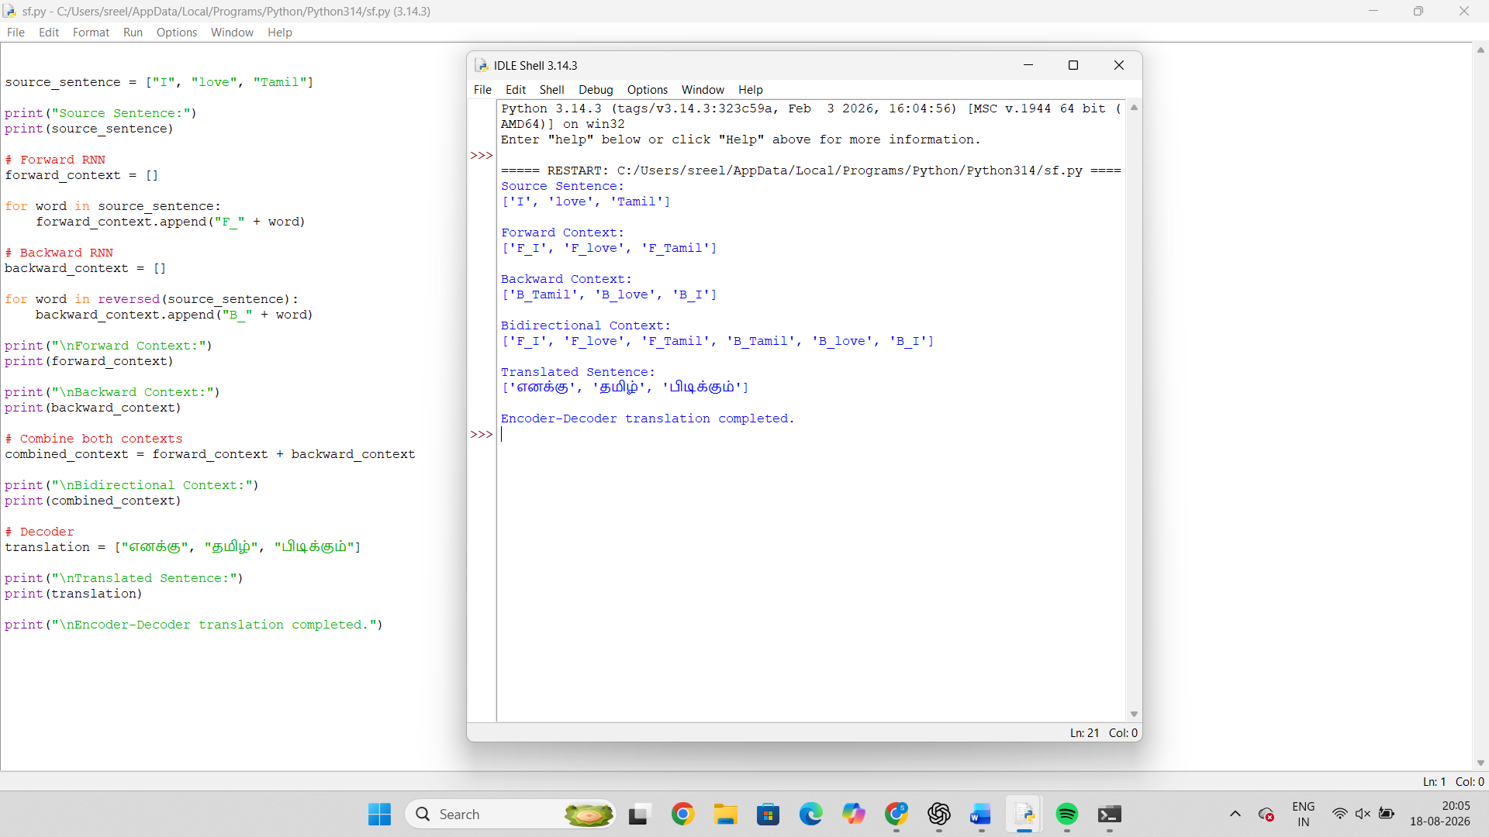

Q4. BPTT + LSTM – Stock Market Prediction

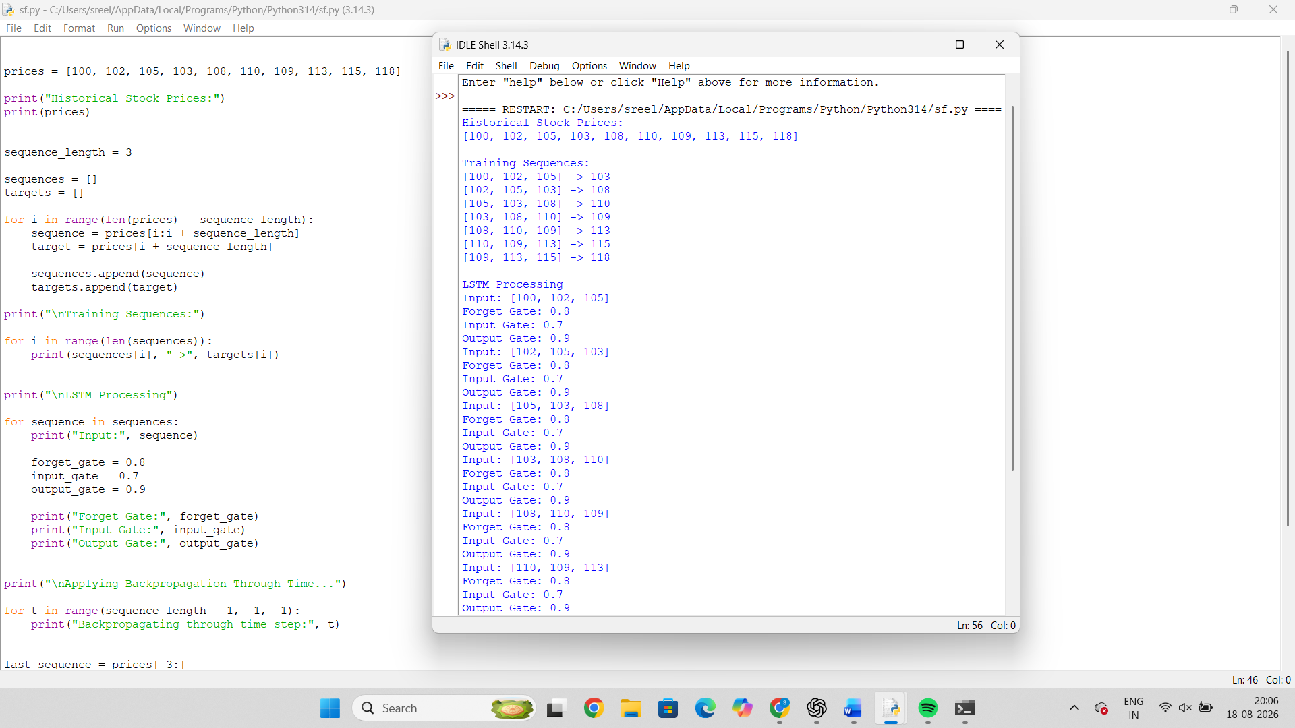
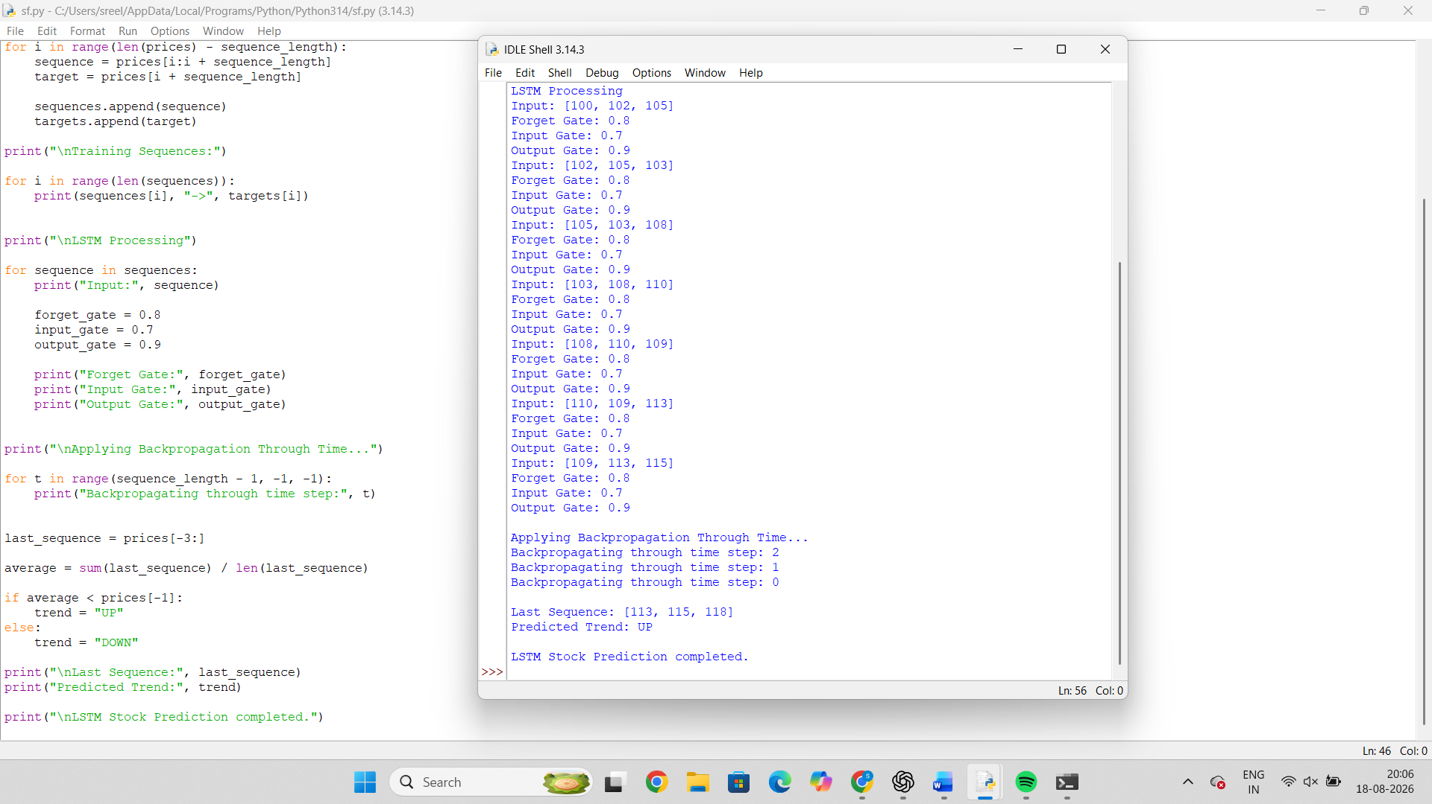

Q5. Integrated Deep Learning – Video Caption Generation

